A PROJECT REPORT

on

“NutriScore: A Deep Learning-based Food Classification System”

Submitted to

KIIT Deemed to be University

In Partial Fulfilment of the Requirement for the Award of

BACHELOR’S DEGREE IN

INFORMATION TECHNOLOGY

BY

Rahul Sah
Aryamanshu Mishra
Shiv Agrawal
Brajesh Mishra

2006185
2006065
2006286
2006212

UNDER THE GUIDANCE OF

Dr. Murari Mandal



SCHOOL OF COMPUTER ENGINEERING

KALINGA INSTITUTE OF INDUSTRIAL TECHNOLOGY

BHUBANESWAR, ODISHA - 751024
May 2020

A PROJECT REPORT

on

“NutriScore: A Deep Learning-based Food Classification System”

Submitted to

KIIT Deemed to be University

In Partial Fulfilment of the Requirement for the Award of

BACHELOR’S DEGREE IN INFORMATION TECHNOLOGY

BY

Rahul Sah
Aryamanshu Mishra
Shiv Agrawal
Brajesh Mishra

2006185
2006065
2006286
2006212

UNDER THE GUIDANCE OF

Dr. Murari Mandal

SCHOOL OF COMPUTER ENGINEERING

KALINGA INSTITUTE OF INDUSTRIAL TECHNOLOGY

BHUBANESWAE, ODISHA -751024

May 2022

KIIT Deemed to be University

School of Computer Engineering
Bhubaneswar, ODISHA 751024

CERTIFICATE

This is certify that the project entitled

“NutriScore: A Deep Learning-based Food Classification System
“

submitted by

Rahul Sah
Aryamanshu Mishra
Shiv Agrawal
Brajesh Mishra

2006185
2006065
2006286
2006212

is a record of bonafide work carried out by them, in the partial fulfilment of the requirement for the award of Degree of Bachelor of Engineering (Computer Sci-ence & Engineering OR Information Technology) at KIIT Deemed to be university, Bhubaneswar. This work is done during year 2022-2023, under our guidance.

Date: / /

Dr. Murari Mandal

Project Guide

Acknowledgements

We are profoundly grateful to Dr. Murari Mandal of Affiliation for his expert guidance and continuous encouragement throughout to see that this project rights its target since its commencement to its completion. .....................

Rahul Sah
Aryamanshu Mishra
Shiv Agrawal
Brajesh Mishra

ABSTRACT

Obesity is one of the contemporary issues we are now facing.But the use of classification to determine the degree of healthiness of food images is still largely unexplored.In order to recognize things through image processing, we are employing deep learning, which is employed in everyday life.Here the model used in this project is ResNet50 which has 50 layers of block and these networks are simpler to optimize and can improve accuracy over significantly more depth.In this project we have built the data set from the already-existing food image datasets (Kaggle).On the basis of classification of data set we have manage to build a scoring system which will have +1 for healthy food and -1 for unhealthy food.

Keywords: Unhealthy,Healthy,Transfer Learning,Deep Learning,ResNet50

Contents

1 | Introduction |  | 1-2
2 | Literature Review |  | 3
 | 2.1 | 2.1 Image Classifier | 4-6
3 | Problem Statement |  | 7
 | 3.1 | System Architecture | 7
4 | Implementation |  | 8
 | 4.1 | Methodology / Proposal ........................... | 8
 | 4.2 | Model Architecture…………………. | 8
 | 4.3 | Result Analysis | 8-10
5 | Conclusion and Future Scope |  | 11
 | 5.1 | Conclusion ……………………….. | 11
 | 5.2 | Future Scope ………………………. | 11-12
References |  |  | 13
Individual Contribution |  |  | 14-17
Plagiarism Report |  |  | 18-20

List of Figures

2.1 | ResNet 50 Model architecture | 6
3.1 | Nutriscore Work Flow | 7
4.3.1: | Result. | 8
4.3.2 | Healthy food image data set example | 9
4.3.3 | Unhealthy food image data set example. | 9
4.3.4 | Locally Deployment of our model using streamlit. | 10

NutriScore: A Deep Learning-based Food Classification System

Chapter 1

Introduction

According to the NFHS study[1], which was conducted between 2019 and 2021, approximately 6.4% of women and 4.0% of men between the ages of 15 and 49 are obese in India.In the same age range, 17.6% of women and 18.9% of men are overweight but not obese.This indicates that almost a fifth of men and a little over a fourth of young women in India are overweight or obese.Another problem is people tend to share food images on social media or simply food marketing which are mainly meals that are high in energy yet lacking in nutrients, such as candy and fried foods. This social media marketing of foods influences people to take this type of food. This is harmful as this high caloric foods can cause long-term illnesses and diseases such as cancer, cardiovascular disease, and obesity which are linked to higher calorie intake, and this type of correlation can have a significant impact on health consequences.Based on this information we understand people behaviour towards food and also how a classification of food as healthy and unhealthy with the scoring system would help promote positive health outcomes.

So for the classification a deep learning has to be applied.Deep learning is basically Computational models with numerous processing layers can learn representations of data at various levels of abstraction thanks to deep learning. The state-of-the-art in many other fields, including drug discovery and genomics, object identification, visual object recognition, and speech recognition has been significantly enhanced by these techniques. By employing the back propagation technique to suggest changes to a machine's internal parameters that are used to compute the representation in each layer from the representation in the previous layer, deep learning can uncover detailed structures in massive data sets. Recurrent nets have shed light on sequential data types like text and speech, whereas deep convolutional nets have made advancements in the processing of pictures, video, speech, and audio.

Deep Convolutional Neural Networks (DCNNs) started to be utilized to extract characteristics that would eventually be used for categorization as the popularity and accessibility of the framework expanded. The well-known CNN designs AlexNet, VGG-16, and GoogleNets can be applied to deep feature extraction [2]. Image classification is a multi-step procedure. First, it must be decided whether or not there is food in the picture. With the help of the Food-5K database, Singla et al. improved a GoogleNet pre-trained model for this task [3]. When separating between food and non-food items, they were able to score a 99.2% accuracy rate.

In order to take use of pre-trained models that were trained on substantial datasets, transfer learning is a popular deep learning technique. The quantity of data and computational resources required to train a new model for a particular job can be decreased by employing a pre-trained model as a starting point. When the task at hand is comparable to the task that the pre-trained model was trained on, or when the dataset size is modest, this strategy is especially helpful.

School of Computer Engineering, KIIT, BBSR 1

NutriScore: A Deep Learning-based Food Classification System

ResNet50 is a well-known pre-trained model employed frequently in image classification applications. It is based on the residual learning architecture and contains 50 layers, making it easier to train deeper networks. By utilizing skip connections, the residual learning architecture enables the network to learn residual functions, or the difference between a layer's input and output, rather than the actual mapping. This strategy has been demonstrated to enhance deep neural network performance while lowering the danger of overfitting.
So for the classification a deep learning has to be applied.Deep learning is basically Computational models with numerous processing layers can learn representations of data at various levels of abstraction thanks to deep learning. The state-of-the-art in many other fields, including drug discovery and genomics, object identification, visual object recognition, and speech recognition has been significantly enhanced by these techniques. By employing the back propagation technique to suggest changes to a machine's internal parameters that are used to compute the representation in each layer from the representation in the previous layer, deep learning can uncover detailed structures in massive data sets. Recurrent nets have shed light on sequential data types like text and speech, whereas deep convolutional nets have made advancements in the processing of pictures, video, speech, and audio.

On the massive ImageNet dataset, which includes more than a million labeled images falling under 1,000 categories, ResNet50 has been pre-trained. The model can learn general features from this pre-training that help it with various image categorization tasks. With just a limited amount of training data, it is possible to get excellent classification accuracy for food images by fine-tuning the pre-trained ResNet50 model on a smaller data set, like a food data set.
In order to take use of pre-trained models that were trained on substantial datasets, transfer learning is a popular deep learning technique. The quantity of data and computational resources required to train a new model for a particular job can be decreased by employing a pre-trained model as a starting point. When the task at hand is comparable to the task that the pre-trained model was trained on, or when the data set size is modest, this strategy is especially helpful.

Overall, deep learning models' accuracy and effectiveness in a range of image classification tasks, including food categorization, may be enhanced by transfer learning with pre-trained models like ResNet50.

School of Computer Engineering, KIIT, BBSR 2

NutriScore: A Deep Learning-based Food Classification System

Chapter 2

Literature Review

Classifying food is a complicated task as there are variety of foods nation wide.Taking india itself where there are 28 states and each and very state have their own foods.Feature extraction for picture classification was formerly done manually. This method was time-consuming, and it was inevitable that the number of food groups recognized was constrained . During this time, textural features like local binary patterns (LBP) and Speed-Up-Robust Features (SURF) were frequently used by researchers to aid in classification . In one study, HSV colours and Scale Invariant Feature Transform were used as features in a bag of features model [4]. 78% classification accuracy was attained by an SVM employing these features [4].

Shroff et al.'s [5] introduction of a food identification programme allowed for categorising fast food photographs into four categories. The recognition accuracy for hamburgers, fries, chicken nuggets, and apple pies, respectively, was on the order of 95%, 80%, 90%, and 90% for each segmented food item after a vector of colour (normalised RGB values), size, texture (local entropy, standard deviation, range), shape, and context-based features were computed and fed to an artificial neural network (ANN). By combining a support vector machine (SVM) classifier with a combination of colour (pixel intensities and colour components) and texture (Gabor filter responses) information, Zhu et al. [6] were able to recognise 19 different food classes with an accuracy of 94%.

According to Kong and Tan [7], food items can be matched to photos of quick food, handmade food, and fruits in a food database using scale-invariant feature transform (SIFT) features that have been clustered into visual words. Given that the database contains more than 50 references for each food class and that there are fewer than six food items that need to be recognised, a recognition performance of 92% was recorded.

School of Computer Engineering, KIIT, BBSR 3

NutriScore: A Deep Learning-based Food Classification System

2.1 Image Classification
The biological sciences are increasingly adopting a potent machine learning technique that enables computers to address perceptual challenges like picture and speech recognition[8]. Multiple processing layers are used by these deep-learning techniques, such as deep artificial neural networks, to find patterns and structure in very large data sets. Each layer derives an idea from the data that later layers can build upon; as the level increases, the learnt concepts become more abstract. Deep learning automatically extracts features without relying on previous data processing.

CNN is one of the popularly used method in many research as the CNN's key benefit over its forerunners is that it recognises important elements without human intervention, making it the most popular.The CNN algorithm is the most well-known and frequently used one in the field of DL [9, 10]. The fundamental advantage of CNN over its forerunners is that it does it without human intervention, automatically identifying the pertinent elements [11]. Many different fields, including computer vision [12], speech processing, face recognition , etc., have made extensive use of CNNs. CNNs have a structure akin to a traditional neural network and were modeled after the neurons found in human and animal brains. More specifically, the visual cortex of a cat's brain comprises a complex pattern of cells, and the CNN simulates this pattern [80].
The most typical CNN architectures , are the AlexNet network and the High-Resolution network (HR.Net).CNN's main advantages are equal representations, sparse interactions, and parameter sharing. In contrast to typical fully connected (FC) networks, CNN takes full advantage of 2D input-data structures like image signals by using shared weights and local connections. This technique uses a remarkably minimal number of parameters, streamlining training and accelerating the network. The visual cortex cells also possess this property. These cells, which spatially extract the local correlation present in the input like local filters over the input, are notable for sensing only tiny portions of a scene as opposed to the entire scene.

On the other hand, training CNNs from scratch on a large dataset can be costly in terms of computation and time. Additionally, not all image classification tasks will have access to the large amount of labelled training data that may be necessary and also the CNN performance stagnates or worsens as we add more layers to them. The cause of this is the vanishing gradient issue. Gradients become vanishingly small as a result of back propagation through the deep neural network and repeated multiplication, which results in the issue.

School of Computer Engineering, KIIT, BBSR 4

NutriScore: A Deep Learning-based Food Classification System

These issues in CNNs can be solved using the approach of transfer learning. Using a pre-trained CNN model that has been trained on a sizable dataset, transfer learning entails extracting characteristics from new images. In order to begin the new picture classification task, the pre-trained CNN model can draw on a collection of generic features that it has already learnt from the huge dataset.

The pre-trained CNN model is frequently employed as a fixed feature extractor in transfer learning. A new classifier that is trained on a smaller dataset tailored to the new job uses the output from the final layer of the CNN as input. During this process, only the weights of the new classifier are updated, not the weights of the pre-trained CNN model.

Using transfer learning in CNNs has a number of advantages. The pre-trained CNN model has already learnt a set of generic features from a sizable dataset, which can save a lot of time and processing resources. Second, transfer learning, which makes use of the information gained from a larger dataset, can enhance the performance of CNNs on smaller datasets.Third, the CNN model's pre-trained weights are frozen. Transfer learning can enhance CNN performance on image classification tasks while also conserving time and computational resources by using a pre-trained CNN model as a feature extractor. Last but not least, transfer learning can assist in overcoming the problem of little labelled data by using features discovered from a bigger dataset to categorise new photos with little labelled data.

In conclusion, transfer learning is an effective method for overcoming the difficulties of training CNNs from scratch on smaller datasets. Transfer learning can enhance CNN performance on image classification tasks while also conserving time and computational resources by using a pre-trained CNN model as a feature extractor.
Deep neural network architecture known as Residual Network (ResNet) has been extensively applied to a variety of computer vision problems, including segmentation, object detection, and image categorization. The vanishing gradient problem, in which gradients get progressively smaller as they pass through more layers, is one of the primary difficulties in efficiently training deep neural networks.
By implementing identity shortcut connections or skip connections that omit one or more tiers, ResNet addresses this issue. ResNet makes it possible for the gradient to move through the network more readily, improving the efficiency of model training. The layer N output is connected to the layer N+Z input via shortcut connections, where Z is a hyperparameter that controls how many layers are skipped.

School of Computer Engineering, KIIT, BBSR 5

NutriScore: A Deep Learning-based Food Classification System

ResNet50, a ResNet version with 50 layers, was employed in this project. ImageNet, a sizable data set of around 1.2 million images divided into 1,000 classes, served as the training ground for ResNet50. The learned features and weights are applied to the new task using the pre-trained ResNet50 model, which serves as a feature extractor. The model is then adjusted for the new job, which often takes less time than training the model from scratch in terms of iterations or epochs.

The classification performance on the new job can be greatly enhanced by utilising a pre-trained ResNet50 model, which can take use of the learnt features and weights. The fine-tuning procedure preserves the learnt features from the pre-trained model while changing the weights of the new classifier to enable the model to adapt to the new job.

ResNet50 is a potent deep neural network design that can be applied to a variety of computer vision tasks, in conclusion. ResNet50 can successfully address the vanishing gradient problem and enhance the classification performance on new problems with less iterations by utilising shortcut connections and transfer learning.

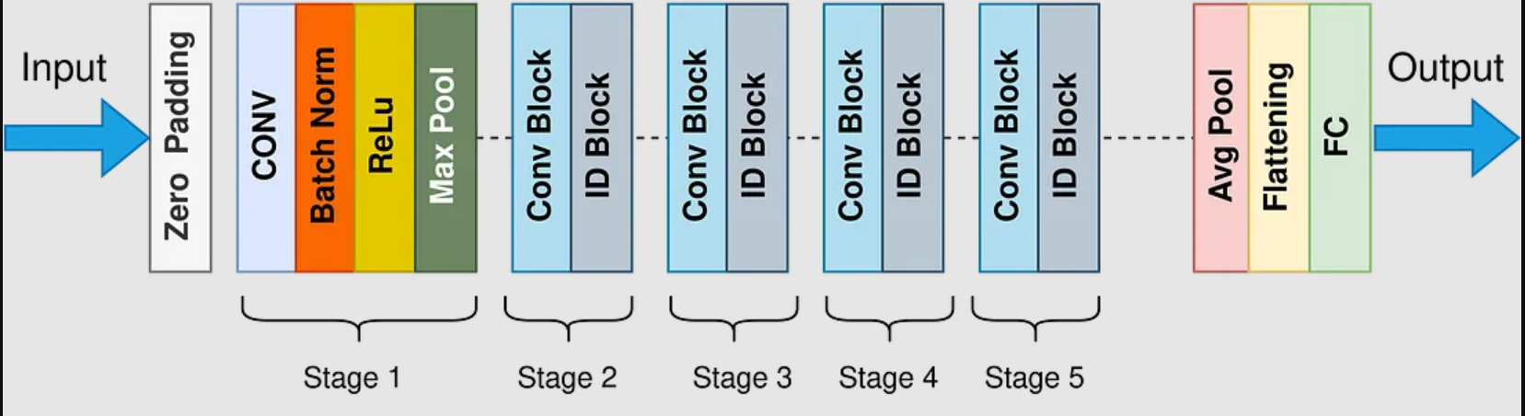

Figure 2.1:ResNet 50 Model architecture

School of Computer Engineering, KIIT, BBSR 6

NutriScore: A Deep Learning-based Food Classification System

Chapter 3

Problem Statement
The objective of this project is to create an image classification model that can distinguish between foods that are healthy and those that are unhealthy. Images of food items should be able to be divided into two groups by the model: healthy and unhealthy. The model should give healthy food items a score of +1 and unhealthy food items a score of -1. To create training, validation, and testing sets, divide the data set. Use transfer learning strategies for training the model.

Deep learning methods will be employed in the model's development. In this project, we will train the image classification model using transfer learning methods. Using the approach of transfer learning, we can use previously learned models as a foundation for new models. This may enable us to use less data while yet getting better outcomes.

3.1 System Architecture
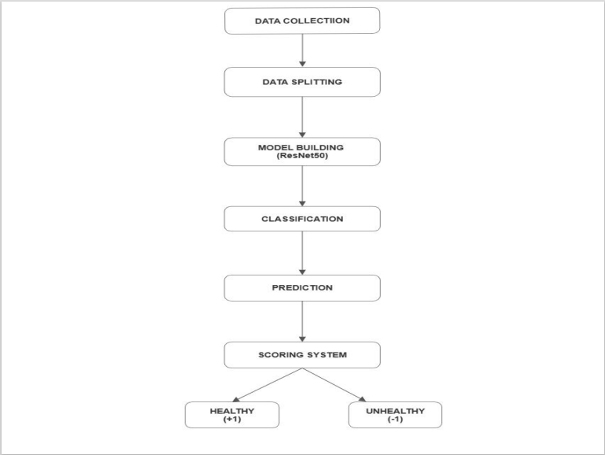

Figure 3.1:Nutriscore Work Flow

School of Computer Engineering, KIIT, BBSR 7

NutriScore: A Deep Learning-based Food Classification System

Chapter 4

Implementation

4.1 Methodology
So at first we collected the data of food images from kaggle then we divided the data into 2 parts healthy and unhealthy handpicking each images from the data sets.Next we loaded the datasets and split the data into 3 batches training, validation and testing.

4.2 Model Architecture
So for this project we have used ResNet50.Deep residual networks are convolutional neural networks (CNNs) with more than 50 layers, like the well-known ResNet-50 model. A Residual Neural Network (ResNet) is a type of Artificial Neural Network (ANN) that builds a network by piling residual blocks on top of one another.

4.3 Result Analysis

In this project the model achieves an accuracy of 89.27% on test batches.

Figure 4.3.1: Result.

School of Computer Engineering, KIIT, BBSR 8

NutriScore: A Deep Learning-based Food Classification System

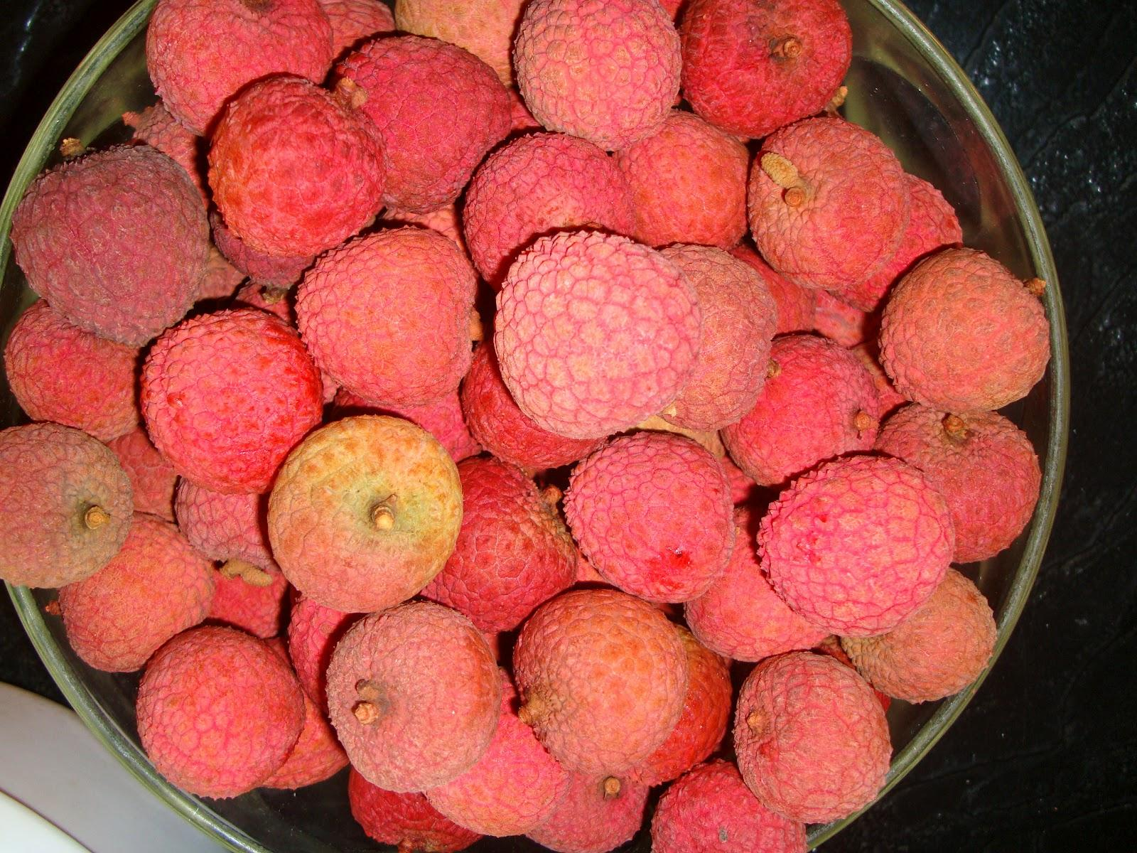
Figure 4.3.2: Healthy food image data set example


Figure 4.3.3:Unhealthy food image data set example.

School of Computer Engineering, KIIT, BBSR 9

NutriScore: A Deep Learning-based Food Classification System

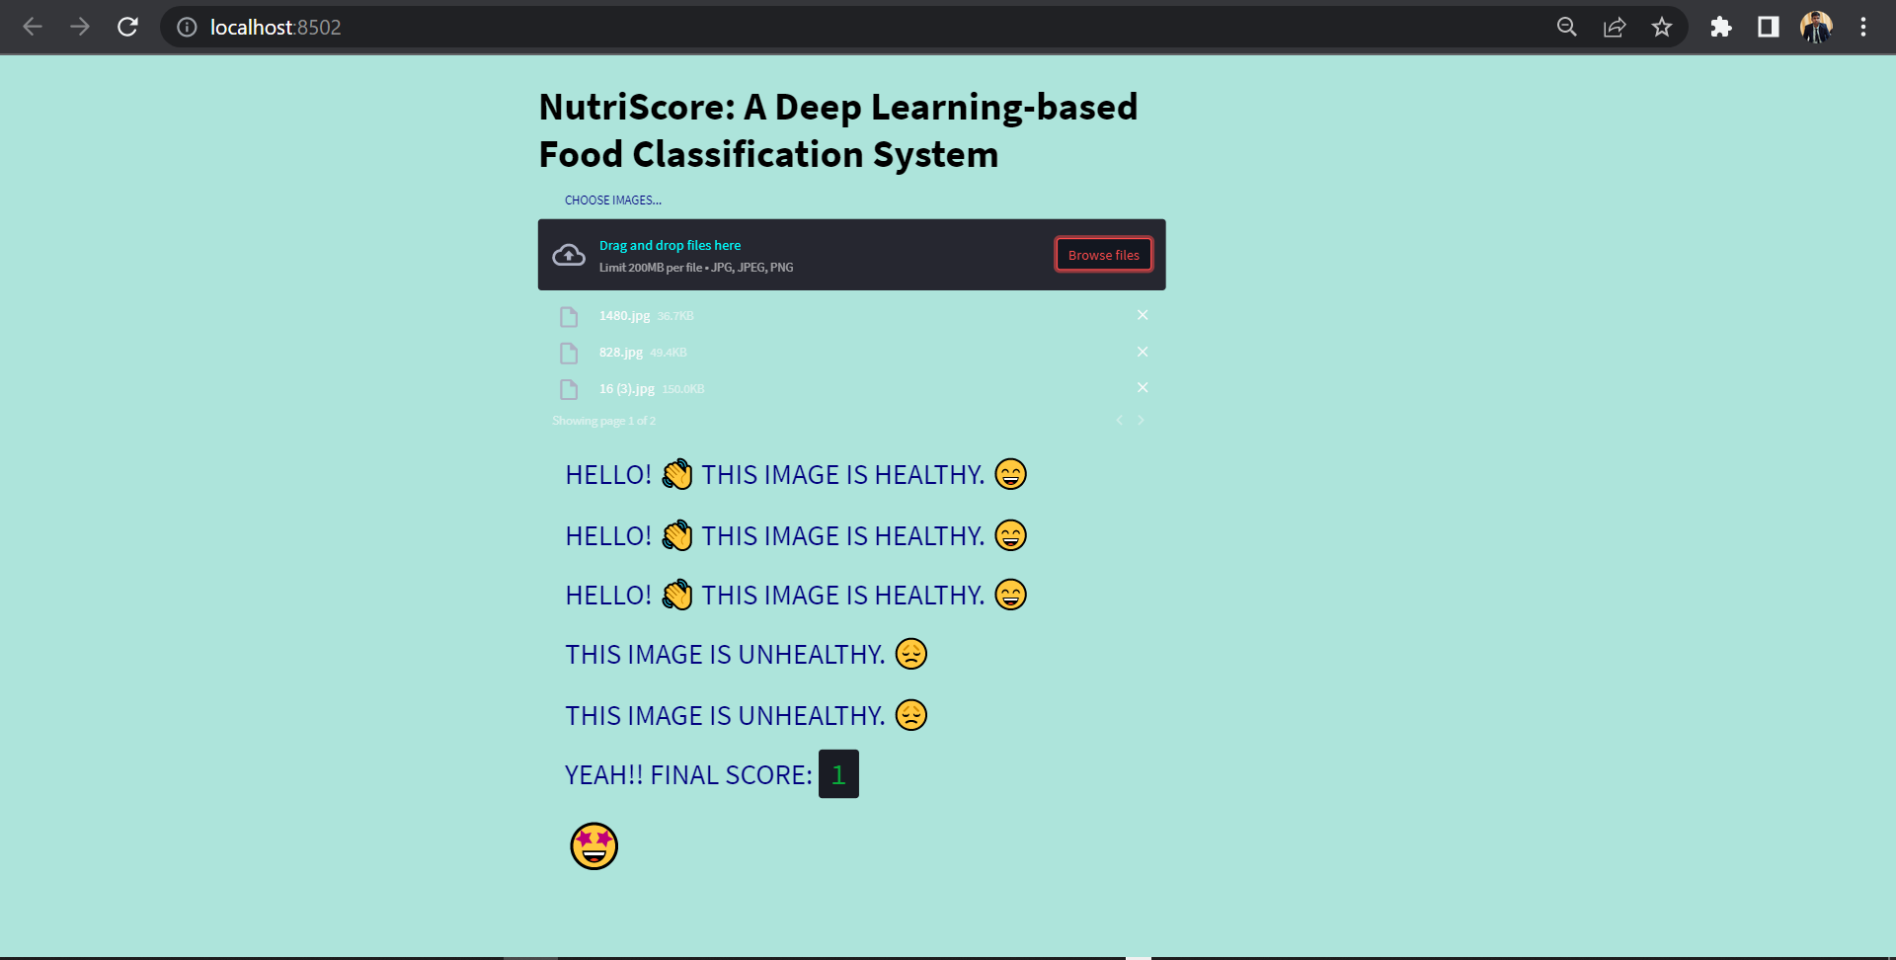
Figure 4.3.4:Locally Deployment of our model using streamlit.

School of Computer Engineering, KIIT, BBSR 10

NutriScore: A Deep Learning-based Food Classification System

Chapter 5
Conclusion and Future Scope

5.1 Conclusion

The project's analysis of food images and assessment of their nutritional value provided a fantastic illustration of the extensive potential of deep learning and image processing techniques. This study created a grading system to classify foods as healthy or unhealthy by combining pre-existing food photo datasets and the ResNet50 model to build a trustworthy and accurate dataset. The grading system offered a quick and easy way to categorize food photographs, with healthy food images receiving a score of +1 and unhealthy food images receiving a score of -1.

This rating system has the potential to be improved and extended further to provide more detailed and in-depth analyses of food images. In the future, this project's score system might be improved by possibly taking into account further elements like serving sizes, preparation techniques, and ingredients. This might lead to a better evaluation of how healthy food images are and further encourage a healthy diet.

Additionally, this plan might have a big impact on public health. This technique enables consumers to make better informed food choices and promotes healthy eating habits by using the devised grading system. Nutritionists and medical professionals may use it as a tool to analyse patients' eating patterns more precisely and make customised recommendations for better health outcomes.

In the end, this project shows how deep learning and image processing techniques have the potential to encourage healthy eating habits and improve public health. The prevalence of diseases associated with inadequate nutrition may diminish, and general health outcomes may improve, with further development and improvement of this strategy.

This project has a promising future thanks to the effective application of deep learning and image processing techniques to evaluate the healthfulness of food photos. This strategy may have major effects on encouraging healthy eating habits and enhancing public health outcomes since it has the ability to develop a more precise grading system and real-time applications.

5.2 Future Scope

Future study can concentrate on expanding the collection to include more types of foods, however the data set utilised in this experiment was built from pre-existing food picture databases. In order to generate a data set that is more diversified and more accurately reflects the enormous variety of foods available around the world, this can be accomplished by gathering photographs from various geographic areas, cuisines, and cultural traditions.

Dietary information can be incorporated into the food classification algorithm to give users more precise and individualized information. The categorization model can suggest foods appropriate for a user's dietary demands and limits by examining the user's dietary data. Individuals with particular dietary needs, such as food allergies, intolerances, or preferences, such as vegan or vegetarian diets, may find this especially helpful.

School of Computer Engineering, KIIT, BBSR 11
The scoring system employed in this study gave good foods a rating of +1 and harmful foods a value of -1. Future studies can improve this rating system by classifying foods in more subtle ways according to their nutritional value and health advantages. A real-time application, such as a smartphone app, can also incorporate the scoring system so that users can take a picture of their food and get a score depending on its health. This can support healthy eating practices and assist people in making better food decisions. Additionally, the scoring system can be used with dietary information to offer individuals personalized recommendations based on their nutritional requirements and health objectives.

Dietary information can be incorporated into the food image categorization algorithm to give users more precise and individualized information. The categorization model can suggest foods appropriate for a user's dietary demands and limits by examining the user's dietary data. Individuals with particular dietary needs, such as those with food allergies, intolerances, or preferences, such as vegan or vegetarian diets, may find this especially helpful.

School of Computer Engineering, KIIT, BBSR 12

NutriScore: A Deep Learning-based Food Classification System

References

- https://theprint.in/health/indians-are-growing-fatter-and-the-problem-is-biggest-for-wealthy-women-shows-nfhs-data/1350501/

- McAllister, P.; Zheng, H.; Bond, R.; Moorhead, A. Combining deep residual neural network features with supervised machine learning algorithms to classify diverse food image datasets. Comput. Biol. Med. 2018, 95, 217–233.

- Singla, A.; Yuan, L.; Ebrahimi, T. Food/Non-food Image Classification and Food Categorization using Pre-Trained GoogLeNet Model. In Proceedings of the 2nd International Workshop on Multimedia Assisted Dietary Management (ACM), Lausanne, Switzerland, 16 October 2016; pp. 3–11.

- M. M. Anthimopoulos, L. Gianola, L. Scarnato, P. Diem and S. G. Mougiakakou, "A Food Recognition System for Diabetic Patients Based on an Optimized Bag-of-Features Model," in IEEE Journal of Biomedical and Health Informatics, vol. 18, no. 4, pp. 1261-1271, July 2014, doi: 10.1109/JBHI.2014.2308928.

- G. Shroff, A. Smailagic and D. P. Siewiorek, "Wearable context-aware food recognition for calorie monitoring", Proc. 12th IEEE Int. Symp. Wearable Comput., pp. 119-120, 2008.

- F. Zhu, M. Bosch, I. Woo, S. Y. Kim, C. J. Boushey, D. S. Ebert, et al., "The use of mobile devices in aiding dietary assessment and evaluation", IEEE J. Sel. Topics Signal Process., vol. 4, no. 4, pp. 756-766, Aug. 2010.

- F. Kong and J. Tan, "DietCam: Automatic dietary assessment with mobile camera phones", Pervasive Mobile Comput., vol. 8, pp. 147-163, Feb. 2012.

- Rusk, N. Deep learning. Nat Methods 13, 35 (2016). https://doi.org/10.1038/nmeth.3707

- Krizhevsky A, Sutskever I, Hinton GE. Imagenet classification with deep convolutional neural networks. Commun ACM. 2017;60(6):84–90.

[10]Zhou DX. Theory of deep convolutional neural networks: downsampling. Neural Netw. 2020;124:319–27.

[11]Gu J, Wang Z, Kuen J, Ma L, Shahroudy A, Shuai B, Liu T, Wang X, Wang G, Cai J, et al. Recent advances in convolutional neural networks. Pattern Recogn. 2018;77:354–77.

[12]Fang W, Love PE, Luo H, Ding L. Computer vision for behaviour-based safety in construction: a review and future directions. Adv Eng Inform. 2020;43:100980.

[9]https://www.hindawi.com/journals/mpe/2021/5843816/

[10]He, K., Zhang, X., Ren, S., & Sun, J. (2015). Deep Residual Learning for Image Recognition. arXiv. https://doi.org/https://arxiv.org/abs/1512.03385v1

[11]Oduru, T.; Jordan, A.; Park, A. Healthy vs. Unhealthy Food Images: Image Classification of Twitter Images. Int. J. Environ. Res. Public Health 2022, 19, 923. https://doi.org/10.3390/ijerph19020923

[12]https://www.kaggle.com/datasets/iamsouravbanerjee/indian-food-images-dataset

[13]https://ieeexplore.ieee.org/stamp/stamp.jsp?tp=&arnumber=10084041&isnumber=10083503

School of Computer Engineering, KIIT, BBSR 13

NutriScore: A Deep Learning-based Food Classification System

SAMPLE INDIVIDUAL CONTRIBUTION REPORT:

NutriScore: A Deep Learning-based Food Classification System

Rahul Sah
2006185
Abstract: Obesity is one of the contemporary issues we are now facing.But the use of classification to determine the degree of healthiness of food images is still largely unexplored.In order to recognize things through image processing, we are employing deep learning, which is employed in everyday life.Here the model used in this project is ResNet50 which has 50 layers of block and these networks are simpler to optimize and can improve accuracy over significantly more depth.In this project we have built the data set from the already-existing food image datasets (Kaggle).On the basis of classification of data set we have manage to build a scoring system which will have +1 for healthy food and -1 for unhealthy food.

Individual contribution and findings:First my teammate collected the data from kaggle and divided it into two parts healthy and unhealthy food images handpicking each images .So, the next which was mine was to decide which model to use and implement it.So at first I tried the CNN model from scratch and run it on the training batches, but the accuracy provided by this model was very less as compared what we needed.So next I tried DensNet121, but this model was also not able to give the accuracy what we needed . After this I used ResNet50 which provided the highest accuracy out of the above two model. So I used ResNet50 for our project.Then after this I have downloaded the model which is there after used by my teammates to deploy this model locally using streamlit.

Individual contribution to project report preparation:In this report I have written about Introduction and Literature review . In the Introduction part I have talked about why we are doing this project what’s the basic idea behind this project.Next I have written about the Literature review where I have gone through multiple research paper from google scholar and others sources, where I have written about why classifying food is a difficult task and few people have worked on it and explained about the model(ResNet50) used in this project.In the subsection I have talked about the Image Classifier(ResNet50) used in this project in depth about how ResNet50 is pre trained on ImageNet data sets which comprises about 1.2 million photos and how the weights from this pre-trained are transferred to model that we are using and many research have shown that this model works better for image classification as compared to other models.

Individual contribution for project presentation and demonstration:In the project presentation I have written about the Introduction,Objective,explained about the model architecture and result part.

Full Signature of Supervisor: Full signature of the student:
Rahul Sah
……………………………. ……………………………..

School of Computer Engineering, KIIT, BBSR 14

NutriScore: A Deep Learning-based Food Classification System

SAMPLE INDIVIDUAL CONTRIBUTION REPORT:

NutriScore: A Deep Learning-based Food Classification System

Aryamanshu Mishra
2006065

Abstract: Obesity is one of the contemporary issues we are now facing.But the use of classification to determine the degree of healthiness of food images is still largely unexplored.In order to recognize things through image processing, we are employing deep learning, which is employed in everyday life.Here the model used in this project is ResNet50 which has 50 layers of block and these networks are simpler to optimize and can improve accuracy over significantly more depth.In this project we have built the data set from the already-existing food image datasets (Kaggle).On the basis of classification of data set we have manage to build a scoring system which will have +1 for healthy food and -1 for unhealthy food.

Individual contribution and findings: My role in this project was to collect food data images.So for this I have used kaggle data sets and for this I taken a food from the data set and checked whether the food is healthy and unhealthy based on it we have divided the food images into two parts.So next thing I did was to load the data set that I made into the google colab, and after this I have splitted the data that I have loaded into google colab into 3 parts in the ratio 60% for training batches,20%validation batches and 20% for test batches.

Individual contribution to project report preparation:So my role in this report presentation was to to write about the problem statement where I have talked about the objective of the project ,what methodology have been used in this project along with a system architecture diagram.

Individual contribution for project presentation and demonstration:For the project presentation I have written about the methodology where I have talked about how the data set I have made.

Full Signature of Supervisor: Full signature of the student:
Aryamanshu Mishra
……………………………. ……………………………..

School of Computer Engineering, KIIT, BBSR 15
NutriScore: A Deep Learning-based Food Classification System

SAMPLE INDIVIDUAL CONTRIBUTION REPORT:

NutriScore: A Deep Learning-based Food Classification System

Shiv Agrawal
2006286

Abstract:Obesity is one of the contemporary issues we are now facing.But the use of classification to determine the degree of healthiness of food images is still largely unexplored.In order to recognize things through image processing, we are employing deep learning, which is employed in everyday life.Here the model used in this project is ResNet50 which has 50 layers of block and these networks are simpler to optimize and can improve accuracy over significantly more depth.In this project we have built the data set from the already-existing food image datasets (Kaggle).On the basis of classification of data set we have manage to build a scoring system which will have +1 for healthy food and -1 for unhealthy food.

Individual contribution and findings:In this project my role in this project was to work in streamlit along with my teammate Brajesh.So in this the scoring system the which as made I have defined a message for each food image uploaded with an emoji based on the type of food whether it is healthy or unhealthy.Along with this I have added CSS into our streamlit in which I have change the background color , size of text,emoji size and small CSS styling elements here and there.

Individual contribution to project report preparation: In this report my role was to do the Implementation part.In the implementation part I have explained about the methodology used ,model Architecture and results screenshots.

Individual contribution for project presentation and demonstration:In the project presentation I have written about the conclusion and future scope of this project.

Full Signature of Supervisor: Full signature of the student:
Shiv Agrawal
……………………………. ……………………………..

School of Computer Engineering, KIIT, BBSR 16
NutriScore: A Deep Learning-based Food Classification System

SAMPLE INDIVIDUAL CONTRIBUTION REPORT:

NutriScore: A Deep Learning-based Food Classification System

Brajesh Mishra
2006212

Abstract: Obesity is one of the contemporary issues we are now facing.But the use of classification to determine the degree of healthiness of food images is still largely unexplored.In order to recognize things through image processing, we are employing deep learning, which is employed in everyday life.Here the model used in this project is ResNet50 which has 50 layers of block and these networks are simpler to optimize and can improve accuracy over significantly more depth.In this project we have built the data set from the already-existing food image datasets (Kaggle).On the basis of classification of data set we have manage to build a scoring system which will have +1 for healthy food and -1 for unhealthy food.

Individual contribution and findings:My role in this project was to work in the streamlit part where I deployed the model .In this I made the part where user can upload multiple images and is stored in an array.Next I made the for loop to iterate through images uploaded and predict images using the model whether it is healthy or unhealthy and based on the type of image made a scoring system where for a healthy food image a score of +1 would be given and for an unhealthy food image the score of -1 is given .

Individual contribution to project report preparation:In this report I have written about Conclusion and Future Scope.So in this basically I have conclude about how we have done this project like how the data set was build and the model used in this model(ResNet50),based on the classification providing a score.Next think I talked about is the future scope of this project like making a Real-time applications,Incorporating dietary data and increase the data set images.

Individual contribution for project presentation and demonstration:For the project presentation I have written about the deployment part of the project.

Full Signature of Supervisor: Full signature of the student:
Brajesh Mishra
……………………………. ……………………………..

School of Computer Engineering, KIIT, BBSR 17



School of Computer Engineering, KIIT, BBSR 18



School of Computer Engineering, KIIT, BBSR 19

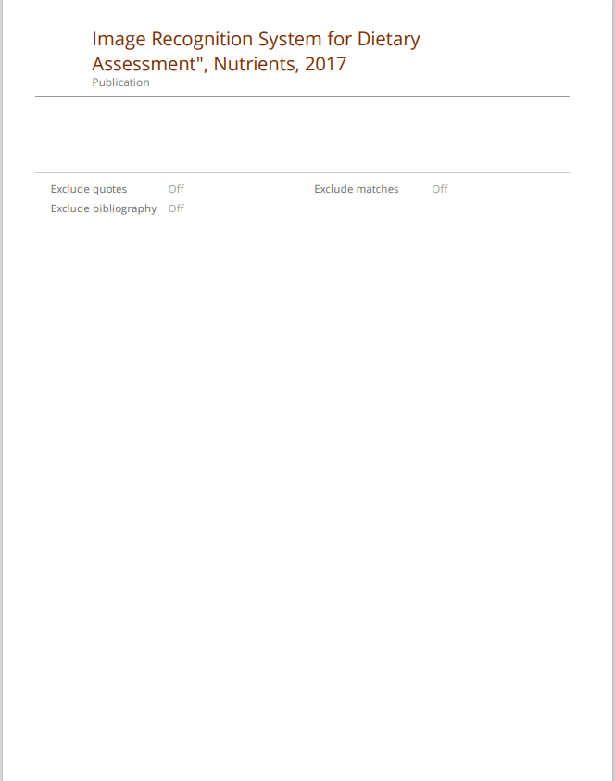

School of Computer Engineering, KIIT, BBSR 20

